WEB FUNDAMENTALS:
SECTION 1: DNS:
DNS stands for Domain Name System. It acts like the phonebook of the Internet. Every device connected to the Internet has a unique address called an IP address (for example, 104.26.10.229). Computers use these IP addresses to find and communicate with each other.
How DNS Works (Step by Step):
- User request: You type a web address (like tryhackme.com) into your browser.
- DNS Resolver: Your computer sends this request to a DNS resolver (usually provided by your Internet Service Provider).
- DNS Lookup: The resolver looks up the IP address by contacting DNS servers — these are like layers of directories that store domain information.
- Response: Once the correct IP address is found, the resolver sends it back to your browser.
- Connection: Your browser now uses that IP address to connect to the website’s server and load the page.

Domain Hierarchy:
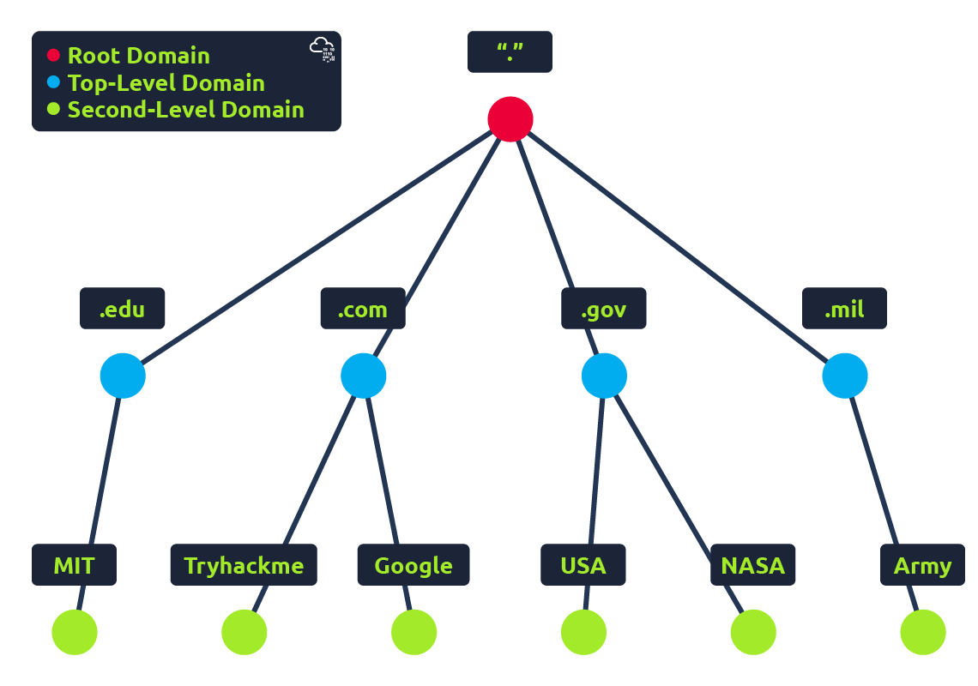
Top Level Domain (TLD):
A Top Level Domain (TLD) is the last part of a website’s domain name.
For example, in the domain tryhackme.com, the TLD is “.com”.
TLDs are managed by an organization called ICANN (Internet Corporation for Assigned Names and Numbers), which controls the overall domain name structure of the Internet.
There are mainly two types of Top-Level Domains:
1. gTLD – Generic Top Level Domain:
- These are not linked to any country but instead to the purpose or type of organization.
- Examples:
.com → Commercial websites
.org → Non-profit organizations
.edu → Educational institutions
.gov → Government websites
2. ccTLD – Country Code Top Level Domain:
- These are two-letter domains that represent specific countries or regions.
- Examples:
  - .in → India
  - .uk → United Kingdom
  - .ca → Canada
  - .au → Australia
- ccTLDs are mainly used for websites that operate in a particular country or serve a local audience.
Second-Level Domain (SLD):
A Second-Level Domain (SLD) is the main part of a domain name that appears just before the Top-Level Domain (TLD).
Example:
In tryhackme.com →
- .com is the TLD (Top-Level Domain)
- tryhackme is the SLD (Second-Level Domain)
Rules for Second-Level Domains
- Can be up to 63 characters long (excluding the TLD).
- Can include letters (a–z), numbers (0–9), and hyphens (-).
- Cannot start or end with a hyphen.
- Cannot have two or more hyphens in a row.
Example of valid domains:
- my-site.com
- tech123.org
Subdomain :
A Subdomain is a part of the domain name that appears to the left of the Second-Level Domain, separated by a dot.
Example:
- In admin.tryhackme.com,
  - admin is the subdomain
  - tryhackme is the Second-Level Domain
  - .com is the TLD

DNS Record Types :
A Record:
These records resolve to IPv4 addresses, for example 104.26.10.229
SYNTAX: nslookup --type=A website.thm
AAAA Record:
These records resolve to IPv6 addresses, for example 2606:2331:20::681a
TXT Record :
TXT records are free text fields where any text-based data can be stored. TXT records have multiple uses, but some common ones can be to list servers
MX Record :
These records resolve to the address of the mail servers that handle the email for the domain you are querying, for example an MX record response for tryhackme.com would look something like alt1.aspmx.l.google.com.
SYNTAX: nslookup --type=MX website.thm
CNAME:
It is a type of DNS record used to map one domain name to another.
In simple words, a CNAME acts like a nickname or alias for another domain name.

What happens when you make a DNS request:
- When you request a domain name, your computer first checks its local cache to see if you've previously looked up the address recently; if not, a request to your Recursive DNS Server will be made.
- Recursive DNS Server is usually provided by your ISP, but you can also choose your own. This server also has a local cache of recently looked up domain names. If a result is found locally, this is sent back to your computer, and your request ends here (this is common for popular and heavily requested services such as Google, Facebook, Twitter).
- The root servers act as the DNS backbone of the internet; their job is to redirect you to the correct Top Level Domain Server, depending on your request. If, for example, you request www.tryhackme.com, the root server will recognise the Top Level Domain of .com and refer you to the correct TLD server that deals with .com addresses.
- TLD Server
The Top Level Domain (TLD) server manages addresses for specific extensions like:
- .com, .org, .net, .in, etc.
This server doesn’t know the website’s IP either but tells the recursive server where to find the authoritative nameserver for that domain.
Example:
For tryhackme.com, the TLD server points to:
kip.ns.cloudflare.com and uma.ns.cloudflare.co
- An authoritative DNS server is the server that is responsible for storing the DNS records for a particular domain name and where any updates to your domain name DNS records would be made. Depending on the record type, the DNS record is then sent back to the Recursive DNS Server. DNS records all come with a TTL (Time To Live) value. This value is a number represented in seconds that the response should be saved for locally until you have to look it up again. Caching saves on having to make a DNS request every time you communicate with a server.

- Computer cache
- Recursive DNS
- Root Server
- TLD Server
- Authoritative Server
- Result cached for future use
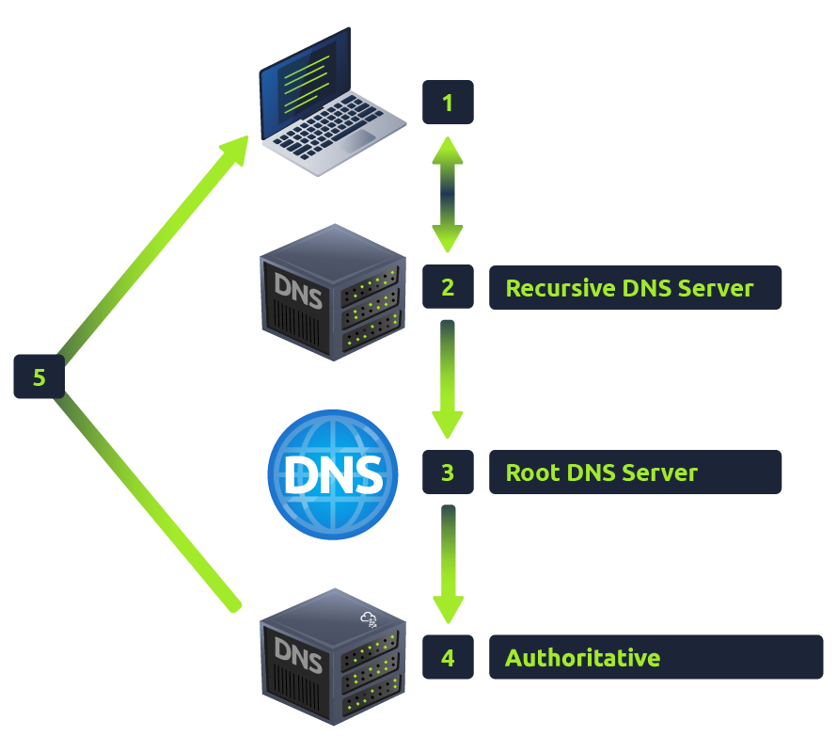

SECTION 2 : HTTP in Detail
What is HTTP? (HyperText Transfer Protocol):
HTTP is what's used whenever you view a website, is the set of rules used for communicating with web servers for the transmitting of webpage data, whether that is HTML, Images, Videos, etc.
What is HTTPS? (HyperText Transfer Protocol Secure):
HTTPS is the secure version of HTTP. HTTPS data is encrypted so it not only stops people from seeing the data you are receiving and sending, but it also gives you assurances that you're talking to the correct web server and not something impersonating it.
What is a URL? (Uniform Resource Locator):
A URL is predominantly an instruction on how to access a resource on the internet.
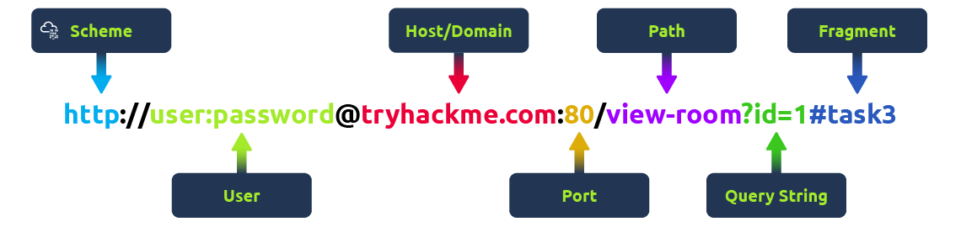
Scheme: This instructs on what protocol to use for accessing the resource such as HTTP, HTTPS, FTP (File Transfer Protocol).
User: Some services require authentication to log in, you can put a username and password into the URL to log in.
Host: The domain name or IP address of the server you wish to access.
Port: The Port that you are going to connect to, usually 80 for HTTP and 443 for HTTPS, but this can be hosted on any port between 1 - 65535.
Path: The file name or location of the resource you are trying to access.
Query String: Extra bits of information that can be sent to the requested path. For example, /blog?id=1 would tell the blog path that you wish to receive the blog article with the id of 1.
Fragment: This is a reference to a location on the actual page requested.
Making a Request
It's possible to make a request to a web server with just one line GET / HTTP/1.1
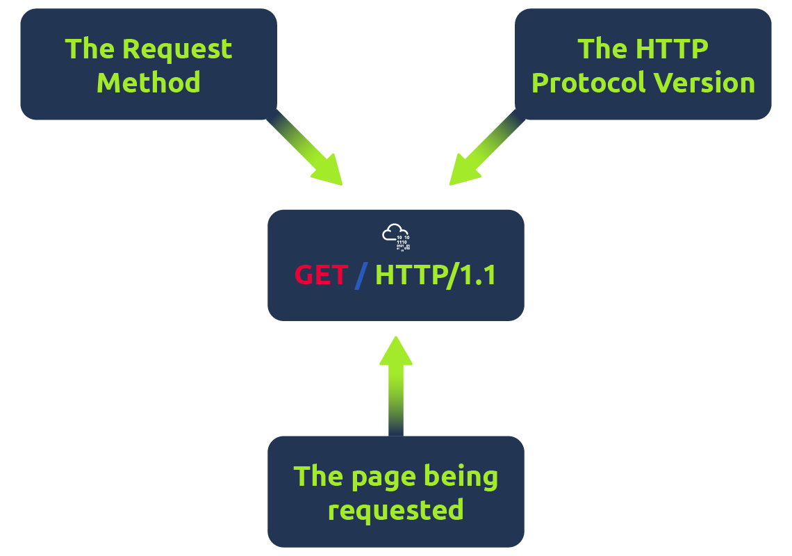
Example Request:
GET / HTTP/1.1
Host: tryhackme.com
User-Agent: Mozilla/5.0 Firefox/87.0
Referer: https://tryhackme.com/
To breakdown each line of this request:
Line 1: This request is sending the GET method ( more on this in the HTTP Methods task ), request the home page with / and telling the web server we are using HTTP protocol version 1.1.
Line 2: We tell the web server we want the website tryhackme.com
Line 3: We tell the web server we are using the Firefox version 87 Browser
Line 4: We are telling the web server that the web page that referred us to this one is https://tryhackme.com
Line 5: HTTP requests always end with a blank line to inform the web server that the request has finished.
Response:
HTTP/1.1 200 OK
Server: nginx/1.15.8
Date: Fri, 09 Apr 2021 13:34:03 GMT
Content-Type: text/html
Content-Length: 98
<html>
<head>
<title>TryHackMe</title>
</head>
<body>
Welcome To TryHackMe.com
</body>
</html>
To breakdown each line of the response:
Line 1: HTTP 1.1 is the version of the HTTP protocol the server is using and then followed by the HTTP Status Code in this case "200 OK" which tells us the request has completed successfully.
Line 2: This tells us the web server software and version number.
Line 3: The current date, time and timezone of the web server.
Line 4: The Content-Type header tells the client what sort of information is going to be sent, such as HTML, images, videos, pdf, XML.
Line 5: Content-Length tells the client how long the response is, this way we can confirm no data is missing.
Line 6: HTTP response contains a blank line to confirm the end of the HTTP response.
Lines 7-14: The information that has been requested, in this instance the homepage.

HTTP Methods:
GET Request:
This is used for getting information from a web server.
POST Request:
This is used for submitting data to the web server and potentially creating new records.
PUT Request:
This is used for submitting data to a web server to update information.
DELETE Request:
This is used for deleting information/records from a web server.

HTTP Status Codes:
These status codes can be broken down into 5 different ranges:
100-199 - Information Response:
These are sent to tell the client the first part of their request has been accepted and they should continue sending the rest of their request. These codes are no longer very common.
200-299 – Success:
This range of status codes is used to tell the client their request was successful.
300-399 – Redirection:
These are used to redirect the client's request to another resource. This can be either to a different webpage or a different website altogether.
400-499 - Client Errors:
Used to inform the client that there was an error with their request.
500-599 - Server Errors :
This is reserved for errors happening on the server-side and usually indicate quite a major problem with the server handling the request.

Common HTTP Status Codes:
200 – OK: The request was completed successfully.
201 – Created: A resource has been created (for example a new user or new blog post).
301- Moved Permanently: This redirects the client's browser to a new webpage or tells search engines that the page has moved somewhere else and to look there instead.
302 – Found: Similar to the above permanent redirect, but as the name suggests, this is only a temporary change and it may change again in the near future.
400 - Bad Request: This tells the browser that something was either wrong or missing in their request. This could sometimes be used if the web server resource that is being requested expected a certain parameter that the client didn't send.
401 - Not Authorized : You are not currently allowed to view this resource until you have authorised with the web application, most commonly with a username and password.
403 – Forbidden: You do not have permission to view this resource whether you are logged in or not.
404 - Page Not Found: The page/resource you requested does not exist.
405 - Method Not Allowed:
500 - Internal Service Error: The server has encountered some kind of error with your request that it doesn't know how to handle properly.
503 - Service Unavailable: This server cannot handle your request as it's either overloaded or down for maintenance.
Headers:
Headers are additional bits of data you can send to the web server when making requests.Although no headers are strictly required when making a HTTP request, you’ll find it difficult to view a website properly.
Common Request Headers
﻿These are headers that are sent from the client (usually your browser) to the server:
Host:
- Identifies the specific website or domain the client wants to reach.
- Example value: Host: www.google.com
User-Agent:
- Tells the server about the browser and operating system being used.
- Example: User-Agent: Mozilla/5.0 (Windows NT 10.0; Win64; x64) Chrome/120.0
Content-Length:
- Indicates the size of the data being sent to the server (like when submitting a form).
- Example: Content-Length: 256.
Accept-Encoding:
- Specifies which compression types the browser supports (like gzip, br, deflate).
- Example: Accept-Encoding: gzip, deflate.
• Cookie:
- Sends stored data (like login info or preferences) back to the server.
  - Example: Cookie: session=12345; theme=dark
Common Response Headers
These are sent from the server back to the client (browser) as part of the response.
- Set-Cookie:
- Used by the server to store information (like session data) in the client’s browser.
- Example: Set-Cookie: user_id=789; Path=/;
2. Cache-Control:
- Tells the browser how long it can store the content before requesting it again.
- Example: Cache-Control: max-age=3600 (cache for 1 hour)
3. Content-Type:
- Specifies the type of data sent in the response.
- Helps the browser know how to display or handle it.
- Examples:
  - Content-Type: text/html (for web pages)
  - Content-Type: image/png (for images)
  - Content-Type: application/json (for API data)
5.Content-Encoding:
- Shows the compression method used for the response data.
- The browser decompresses it before displaying.
- Example: Content-Encoding: gzip.

Cookies:
They're just a small piece of data that is stored on your computer. Cookies are saved when you receive a "Set-Cookie" header from a web server. Then every further request you make, you'll send the cookie data back to the web server.
Because HTTP is stateless (doesn't keep track of your previous requests), cookies can be used to remind the web server who you are, some personal settings for the website or whether you've been to the website before. Let's take a look at
This as an example HTTP request:

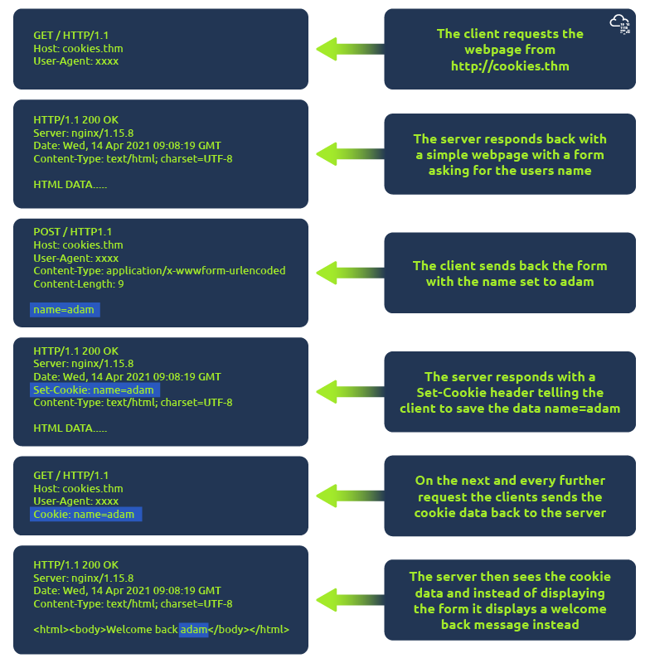
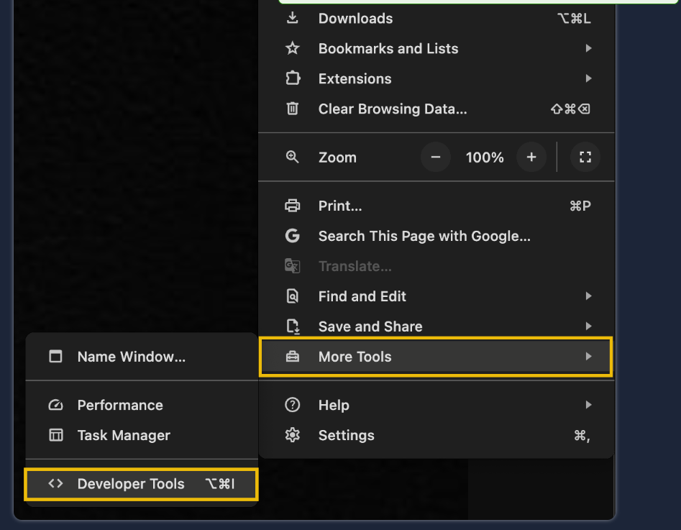

Once you have developer tools open, click on the "Network" tab. This tab will show you a list of all the resources your browser has requested. You can click on each one to receive a detailed breakdown of the request and response. If your browser sent a cookie, you will see these on the "Cookies" tab of the request.

SECTION 3: How Websites Work:
When you visit a website, your browser (like Safari or Google Chrome) makes a request to a web server asking for information about the page you're visiting. It will respond with data that your browser uses to show you the page; a web server is just a dedicated computer somewhere else in the world that handles your requests.
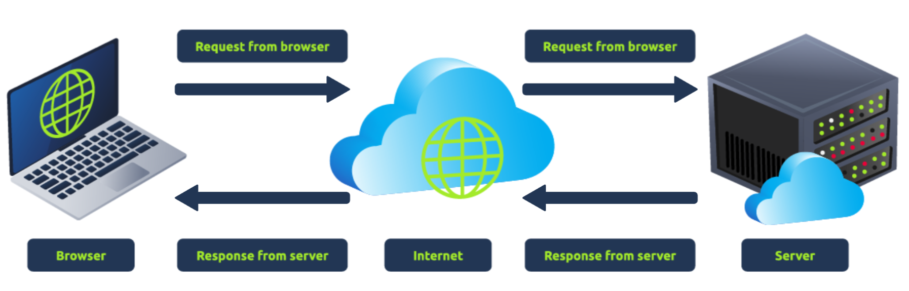
There are two major components that make up a website:
- Front End (Client-Side) - the way your browser renders a website.
- Back End (Server-Side) - a server that processes your request and returns a response.
HTML:
- HTML, to build websites and define their structure
- CSS, to make websites look pretty by adding styling options
- JavaScript, implement complex features on pages using interactivity
HyperText Markup Language (HTML) is the language websites are written in. Elements (also known as tags) are the building blocks of HTML pages and tells the browser how to display content. The code snippet below shows a simple HTML document, the structure of which is the same for every website:
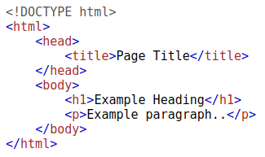
The HTML structure (as shown in the screenshot) has the following components:
- The <!DOCTYPE html> defines that the page is a HTML5 document. This helps with standardisation across different browsers and tells the browser to use HTML5 to interpret the page.
- The <html> element is the root element of the HTML page - all other elements come after this element.
- The <head> element contains information about the page (such as the page title)
- The <body> element defines the HTML document's body; only content inside of the body is shown in the browser.
- The <h1> element defines a large heading
- The <p> element defines a paragraph
- There are many other elements (tags) used for different purposes. For example, there are tags for buttons (<button>), images (<img>), lists, and much more.
JavaScript:
JavaScript (JS) is one of the most popular coding languages in the world and allows pages to become interactive. HTML is used to create the website structure and content, while JavaScript is used to control the functionality of web pages - without JavaScript, a page would not have interactive elements and would always be static. JS can dynamically update the page in real-time, giving functionality to change the style of a button when a particular event on the page occurs (such as when a user clicks a button) or to display moving animations.
JavaScript is added within the page source code and can be either loaded within <script> tags or can be included remotely with the src attribute: <script src="/location/of/javascript_file.js"></script>
Other components:
Load Balancers:
A load balancer shares website traffic between many servers so that no single server gets overloaded.
It makes websites faster and prevents crashes.
It also checks which server is working (health check) and stops sending traffic to a server if it fails.
Common methods are:
- Round-Robin: Each request is sent to servers one by one in a circular order.
- Weighted (Least Connection): The load balancer checks which server is least busy and sends the next request to that one.

CDN (Content Delivery Network):
- A CDN stores copies of a website’s static files (like images, videos, CSS, and JavaScript) on many servers around the world.

- When someone visits the site, the CDN sends the files from the nearest location, making the website load faster.
- It also reduces the main server’s load and improves user experience.

Databases :
- A database stores and manages all website data — like user accounts, messages, and posts.
- Web servers use databases to save and retrieve data quickly.
- Examples: MySQL, MongoDB, PostgreSQL, MSSQL.
- Databases make websites dynamic and allow users to interact easily.

WAF (Web Application Firewall) :
- A WAF protects a website from hackers and attacks.
- It filters web requests and blocks harmful ones, such as SQL injection or DDoS attacks.
- It also limits how many requests one user can send at a time (rate limiting).
- This keeps the website safe and running smoothly.
In short:
- Load Balancer → shares traffic between servers.
- CDN → delivers files from the nearest server.
- Database → stores and manages website data.
- WAF → protects from hackers and attacks

How Web Servers Work :
Web Server:
- A web server is software that delivers websites to users over the Internet using the HTTP protocol.
- When you type a website address (like www.example.com) in your browser, the web server finds the requested file from its root directory and sends it back to your browser.
- Example: For Linux servers (Apache or Nginx), the default root is /var/www/html
- For Windows servers (IIS), it is C:\inetpub\wwwroot
Common web server software includes Apache, Nginx, IIS, and NodeJS.
Virtual Hosts :
- A single web server can host many websites at once using Virtual Hosts.
- Each virtual host is configured to respond to a specific domain name.
- Example:
- one.com → /var/www/website_one
- two.com → /var/www/website_two
- If no match is found, the default website is shown.
There is no limit to how many websites can be hosted on one server.
Static vs Dynamic Content :
Static Content:
- Files that don’t change, such as images, CSS, JavaScript, or fixed HTML pages.
- The web server sends these files directly without modification.
Dynamic Content:
- Pages that change based on user input or updates, like a blog homepage or search results.
- The content is created by programs running in the Backend using languages such as PHP, Python, or NodeJS.
- The processed HTML is then shown on the Frontend (what users see in the browse
Scripting and Backend Language :
- Backend languages handle data and logic behind the scenes.
They can:
- Communicate with databases
- Process user input
- Generate dynamic pages
Common backend languages: PHP, Python, Ruby, NodeJS, Perl.
Summary :
- Web Server: Delivers websites using HTTP.
- Virtual Hosts: Allow multiple sites on one server.
- Static Content: Fixed files like images or HTML.
- Dynamic Content: Changes based on user or database.
- Backend Languages: Create interactive and data-driven websites.

